1:ORDERS:

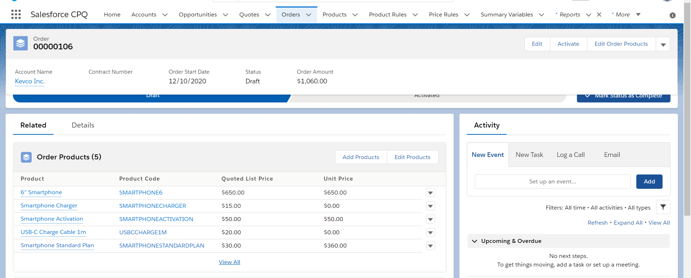

LWC:

HTML:

<template>

<lightning-record-form record-id={recordId} object-api-name="Logistics" layout-type="Full" columns="4" mode="edit"

onsuccess={handleSuccess} onsubmit={handleSubmit}>

</lightning-record-form>

</template>

JS:

import { LightningElement, api } from 'lwc';

import { ShowToastEvent } from 'lightning/platformShowToastEvent';

import logistic_OBJECT '@salesforce/shema/Logistics';

import Name_FIELD from '@salesforce/schema/Logistics.Customer Name';

import Location_FIELD from '@salesforce/schema/Logistics.Customer Location';

import Picup_FIELD from '@salesforce/schema/Logistics.Picup Address';

import del_FIELD from '@salesforce/schema/Logistics.Delivery Address';

export default class customer extends LightningElement {

@api recordId;

@api objectApiName;

fields = [NAME_FIELD,Location_FIELD,Picup_FIELD ,del_FIELD];

handleSubmit(event)

{

console.log('customer detail : ',event.detail.fields);

}

handleSuccess(event) {

const evt = new ShowToastEvent({

title: “get customer details",

message: "Record ID: " + event.detail.id,

variant: "success"

});

this.dispatchEvent(evt);

}

}

XML:

<?xml version="1.0" encoding="UTF-8"?>

<LightningComponentBundle xmlns="http://soap.sforce.com/2006/04/metadata">

<apiVersion>49.0</apiVersion>

<isExposed>true</isExposed>

<targets>

<target>lightning__HomePage</target>

</targets>

</LightningComponentBundle>

2:Quotes:

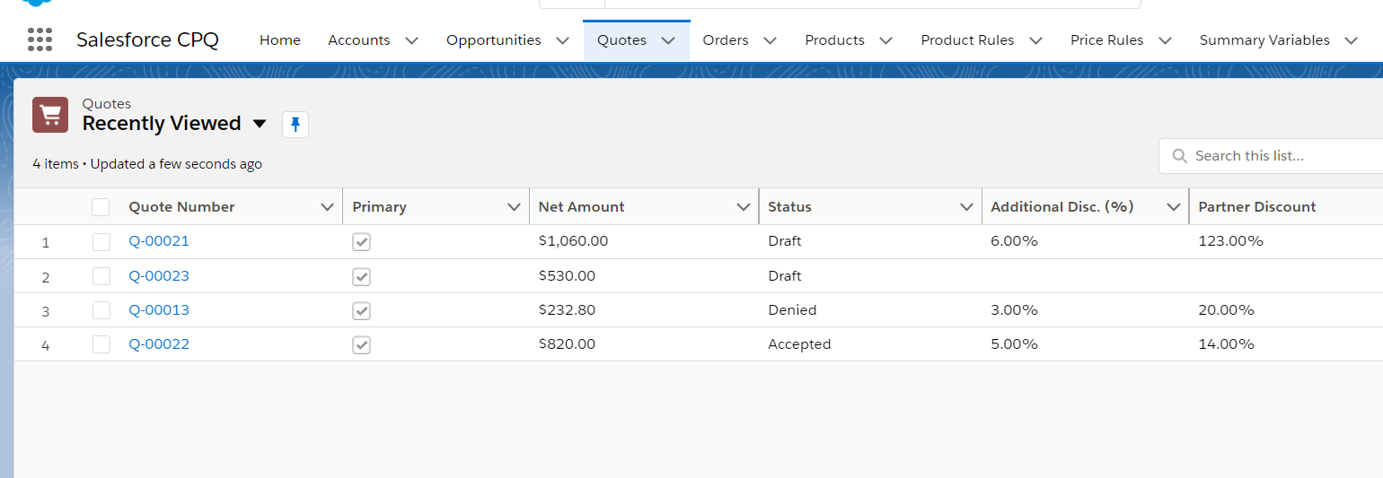

3:Asserts:

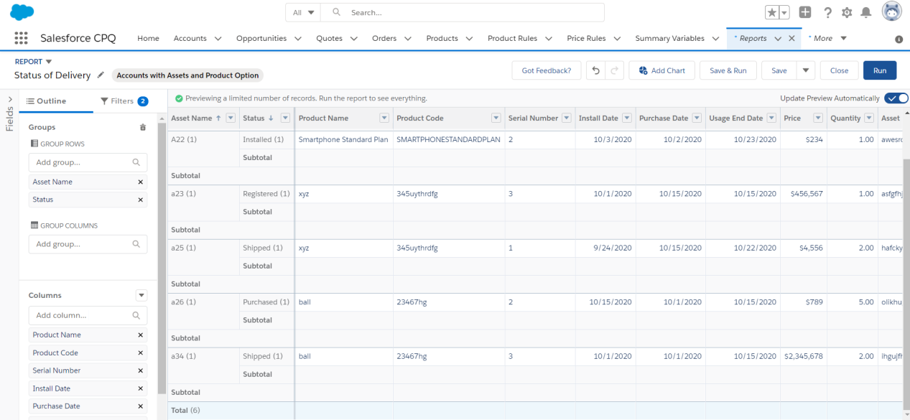

4:VISUAL FORCE TO GENERATE INVOICE:

<apex:page standardController="Customer__c" >

<apex:form>

<apex:pageBlock title="Customer Information">

<apex:pageBlockSection>

<apex:outputField label="CUSTOMER NAME :" value="{! Customer__c.Name }"/>

<apex:outputField label="ADDRESS :" value="{! Customer_c.Address_c }"/>

<apex:outputField label="EMAIL :" value="{! Customer_c.Email_c }"/>

</apex:pageBlockSection>

</apex:pageBlock>

<apex:pageBlock title="Product Details">

<apex:pageBlockSection>

<apex:outputField label="PRODUCT NAME :" value="{! Customer_c.Product_Name_c }"/>

<apex:outputField label="PRODUCT COST :" value="{! Customer_c.Product_Cost_c}"/>

</apex:pageBlockSection>

</apex:pageBlock>

<apex:pageBlock title="Delivery Details">

<apex:pageBlockSection>

<apex:outputField label="DRIVER NAME :" value="{! Customer_c.Driver_Name_c }"/>

<apex:outputField label="DRIVER CHARGE :" value="{! Customer_c.Delivery_Charge_c }"/>

</apex:pageBlockSection>

</apex:pageBlock>

<apex:pageBlock title="Payment Details">

<apex:pageBlockSection>

<apex:outputField label="PRODUCT COST :" value="{! Customer_c.Product_Cost_c}"/>

<apex:outputField label="DELIVERY CHARGE :" value="{! Customer_c.Delivery_Charge_c }"/>

<apex:outputField label="TOTAL COST :" value="{! Customer_c.Total_Cost_c }"/>

</apex:pageBlockSection>

</apex:pageBlock>

</apex:form>

</apex:page>

5:Dashboards:

Status delivery:

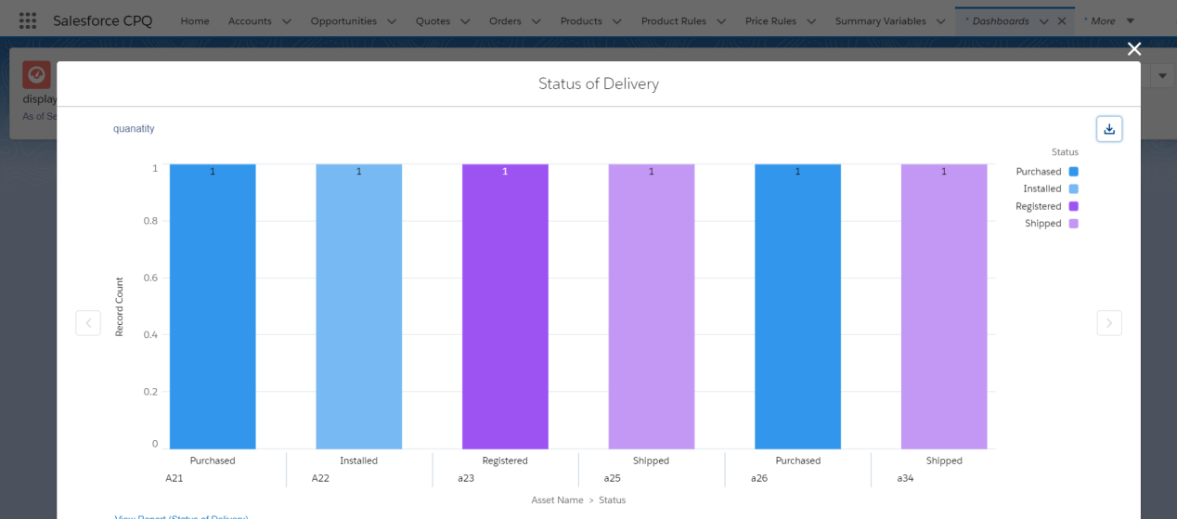

Order History:

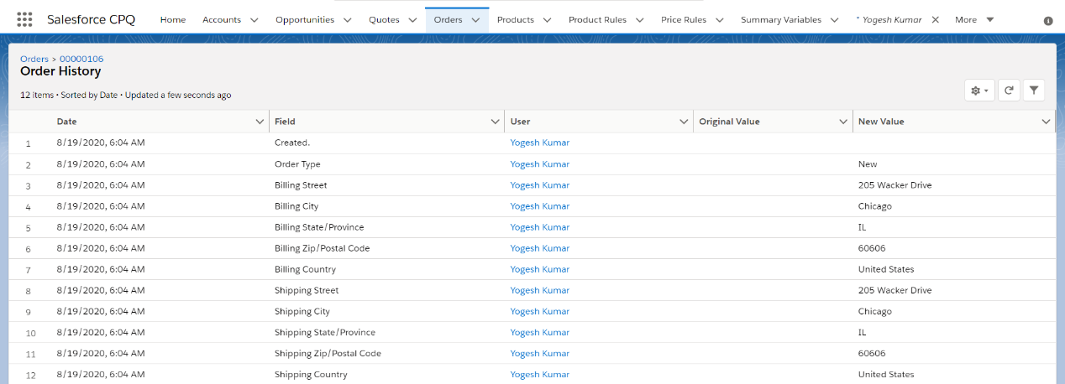

6:Order status:

